**Northern Ireland AHP Research & Innovation Conference 2025**

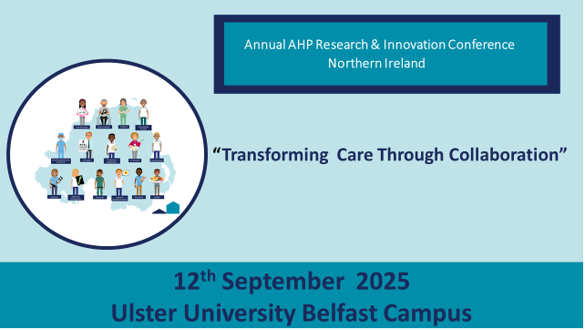

**SUBMISSION OF ABSTRACT GUIDELINES**

**1. Introduction**

Thank you for your interest in submitting an abstract for the N.Ireland AHP Research and Innovation conference 2025. The theme for this year’s conference is “Transforming care through collaboration”

The 2025 conference will be held as a one day event on the 12th September 2025 in the Ulster University, Belfast Campus.

There will be a delegate cost to attend the conference this year. This cost will extend to all delegates including those with successful abstract submissions.

All successful abstract submission delegates will be given priority booking to attend the event.

The 2025 conference will contain key note invited speakers, platform presentation, “rapid-5” (a five-minute presentation of five slides) and posters.

The Poster exhibition will be available to view at any point throughout the conference.

All abstracts will be reproduced for the conference programme.

**2. Important Dates**

**We also welcome submissions from people in all parts of the AHP workforce and at all stages of their careers and actively welcome submission of audit, service evaluation and quality improvement projects.**

|  |  |
| --- | --- |
| Abstract submission opens | 13th Jan 2025 |
| Abstract submission closes- Any abstracts received after this date will not be accepted | 5st May 2025 |
| Abstract submission outcome notification | 30th June 2025 |

All submissions must be received by email to [Helen.Welch@Belfasttrust.hscni.net](mailto:Helen.Welch@Belfasttrust.hscni.net) in the required abstract submission format, any other format will not be considered.

**Please highlight in the email subject; Abstract submission 2025: name of applicant**

**3. Methodology**

Abstracts are invited from the following:

• Qualitative

• Quantitative

• Mixed Methods

• Clinical audit

• Service Evaluation and Quality Improvement

• Case histories

* Patient Stories

**4. General Requirements**

a) Abstracts must be submitted in English. Errors in spelling and grammar cannot be changed before publication so we encourage you to check your spelling and grammar before you submit e.g., use your software spelling and grammar check or ask a colleague to proofread.

b) An abstract must be submitted for each proposed presentation.

c) The maximum word limit for each abstract is 500 words.

d) All abstracts and presentations must adhere to the use of “people-first” language. A person must not be referred to by disability or condition, and terms that could be considered biased or discriminatory in any way should not be used e.g., use “person with a stroke” instead of “stroke patients”.

e) Presenters are requested to disclose actual or potential conflicts of interest regarding their presentation in the first slide. This will allow the audience to take potential conflicts of interest into account when assessing the objectivity of the presentation.

f) Presentations are expected to communicate the same information as your abstract submission, although it can be adapted for the presentation style e.g., adding charts, images or tables and summarising key points. No exceptions will be made.

g) Any changes to the presenting author must be made through the conference organising committee

h) Notification of outcome of the abstract review process will be sent to the submitter. Only the person who submits the abstract will receive email communication about the abstract.

i) Honoraria, fees or payment of expenses will not be provided by the conference committee for authors to present abstracts at the AHP Research & Innovations conference.

**5. Abstract submission format**

**Please complete your 500 word abstract following the guideline provided.**

**The following information should be included on the abstract:**

|  |
| --- |
| **Title of Abstract** |
| **Name Author / co-author** **(please underline presenting author)**  Current appointment / place of work  (this information will be displayed on the programme if you are invited to present)  Email Address for correspondence |
| **Abstract type**  (please clearly state if it is to be considered for platform, rapid 5 or poster only)  ( if abstracts score highly by the scientific committee you may be offered an alternative presentation format i.e poster – rapid 5) |
| **Abstract text**  (This section will ask you to describe in a maximum total of 500 words the purpose, methods, results, conclusions and impact of your work)  (The abstract should not contain bibliographic references, tables or appendices) |
| **Ethical approval**  (This section asks whether your work required ethical approval and to provide details if necessary. Please note that it is recommended for work based within the UK that you use the HRA decision-making tool to confirm whether ethical approval was required or not: [www.hra-decisiontools.org.uk/research](http://www.hra-decisiontools.org.uk/research)) |
| **Funding**  (All sources of financial sponsorship or support of the study should be stated clearly) |

**6. Selection Process**

Submitted abstracts are considered via a blind peer review process. Each abstract will be reviewed by at least two reviewers. The scoring criteria, shown below, are used to review and score all submissions.

Each abstract is scored from 0-18.

All submitted abstracts will be anonymised and peer reviewed without knowledge of the identity of the author(s). Selection of abstracts will be based on how they are scored through the review process against the published criteria. All decisions of the conference organising committee are final. This includes the format for which an abstract is accepted (platform presentation, rapid five or poster).

The scheduling of all presentations will be determined by the programme committee to ensure the best fit with the overall event programme. Any requests for specific times may be considered if travel to the event is deemed an issue. The final decision as to how selected abstracts are allocated is at the discretion of the programme committee.

**Abstract Scoring Criteria**

|  |  |  |  |  |
| --- | --- | --- | --- | --- |
| Criteria | Score 3 | Score 2 | Score 1 | Score 0 |
| Does the abstract match the theme of the conference | Clear link with conference theme in title and content of abstract | Study has adequate link with conference theme | Study has some link with conference theme but not explicit in the abstract submission | No link in title / abstract with conference theme |
| Do the aims and objectives make the purpose clear | Clear aims and objectives | Adequate explanation of aims and objectives | Purpose poorly explained | Purpose cannot be understood |
| Do the methods/ analysis /approach enable the question to be answered | Clear justification for methods / approach used | Adequate justification for method / approach used | Poor justification for methods /approach used | Little / no justification of methods/ approach used |
| Have the results been presented and interpreted accurately | Data / findings presented with clarity | Data / findings present adequately | Data/ findings presented but lack detail | Data/ finding unclear |
| Are the discussion / conclusions consistent with the findings | Findings are well discussed, with clarity about strength / weaknesses and areas for further research | Findings discussed with some interpretation | Poor explanation of findings | Findings of research not explained |
| What is the potential impact to AHP practice | Study has wide impact and likely to be implemented locally / regionally | Study has some impact and likely to be implemented locally | Study has little potential impact and unlikely to be implemented | Study has no impact and no potential to be implemented |

If you require any information regarding the conference or have queries about the abstract submission process please contact [Helen.Welch@Belfasttrust.hscni.net](mailto:Helen.Welch@Belfasttrust.hscni.net)